SAP (SD) SALES AND DISTRIBUTION
2009
VENKAT
WE WILL DEFINE YOUR SAP CAREER
2009
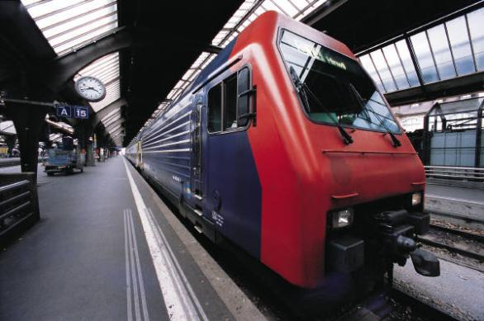
DURATION: 60 hrs CLASS TIME: 1 ½ hrs to 2 hrs

SAP OVERVIEW

1. Master Data
- Organizational Data
- Customer Master Data
- Material Master Data
- Customer Material Information Record
- Document Master Data
- Condition Master Data

2. Sales
- Sales Document Header
- Sales Document Item
- Schedule line Categories
- Copy Control

3. Enterprise Structure
- Client, Company, Company Code, Credit Control Area, Business Area
- Sales Organization, Distribution Channel, Division- Sales area
- Sales Office, Sales group, Sales person
- Plant, Storage location
- Shipping point, Loading point, Transportation Planning point

4. Business processes
- Inquiry
- Quotation
- Standard Order
- Delivery
- Billing

5. Special SD Business processes
- Rush Order
- Cash Sales
- Free of Charge Deliveries
- Free of Charge Subsequent Deliveries
- Contracts
- Scheduling Agreements
- Consignment Stock Process
- Returns
- Credit memo/Debit memo

6. Basic Functions
- Condition Technique
- Pricing With Scales
- Free Goods (Inclusive and Exclusive types)
- Material Determination
- Material Listing/Exclusion
- Cross Selling
- Partner Determination
- Account Determination
- Text Determination
- Output Determination
- Tax Determination
- Route Determination
- Incompletion Log
- Bills of material ( BOM)

7. Shipping
- Shipping doc Types
- Item Categories
- Picking/Packing
- PGI (Post Goods Issue)

8. Billing
9. Credit Management
10. Transfer of Requirements (TOR) & Availability Check
11. Intercompany Billing process
12. Third party order process
13. Integration on
- SD-MM
- SD-PP
- SD-FICO

14. Additional Topics
- General Discussion related SAP SD Interview
- Interview Tips
- Resume Preparation
- Real time Scenarios

ASAP Methodology

